***File Management System***

## Submitted by

**Name of the Students:** Arighna Bhattacharjee

**Enrolment Number:** 12022002003058

**Section:** G

**Class Roll Number:** 27

**Stream:** ECE

**Subject:** Programming for Problem Solving using C

**Subject Code:** ESC103(Pr)

**Department:** Basic Science and Humanities

**Academic Year:** 2022-26



**Department of Basic Science and Humanities, Institute of Engineering and Management**

***Program Code:***

#include <stdio.h>

#include <stdlib.h>

int main()

{

    FILE *fp;

    char filename[50], ch;

    int choice, position, count = 0;

    while (1)

    {

        printf("\nFile Management Operations\n");

        printf("1. Create a new file\n");

        printf("2. Modify an existing file\n");

        printf("3. Delete a file\n");

        printf("4. Exit\n");

        printf("Enter your choice: ");

        scanf("%d", &choice);

        switch (choice)

        {

        case 1:

            printf("\nEnter the filename to create: ");

            scanf("%s", filename);

            fp = fopen(filename, "w");

            if (fp == NULL)

            {

                printf("Error creating file!\n");

                exit(1);

            }

            printf("File created successfully.\n");

            fclose(fp);

            break;

        case 2:

            printf("\nEnter the filename to modify: ");

            scanf("%s", filename);

            fp = fopen(filename, "r+");

            if (fp == NULL)

            {

                printf("Error opening file!\n");

                exit(1);

            }

            fseek(fp, 0, SEEK_END);

            count = ftell(fp);

            printf("The file '%s' contains %d characters.\n", filename, count);

            printf("Enter the position to modify (0-%d): ", count - 1);

            scanf("%d", &position);

            fseek(fp, position, SEEK_SET);

            printf("Enter the new character: ");

            scanf(" %c", &ch);

            fputc(ch, fp);

            fclose(fp);

            printf("File modified successfully.\n");

            break;

        case 3:

            printf("\nEnter the filename to delete: ");

            scanf("%s", filename);

            if (remove(filename) == 0)

            {

                printf("File deleted successfully.\n");

            }

            else

            {

                printf("Error deleting file!\n");

            }

            break;

        case 4:

            exit(0);

        default:

            printf("Invalid choice!\n");

            break;

        }

    }

    return 0;

}

***Output :***

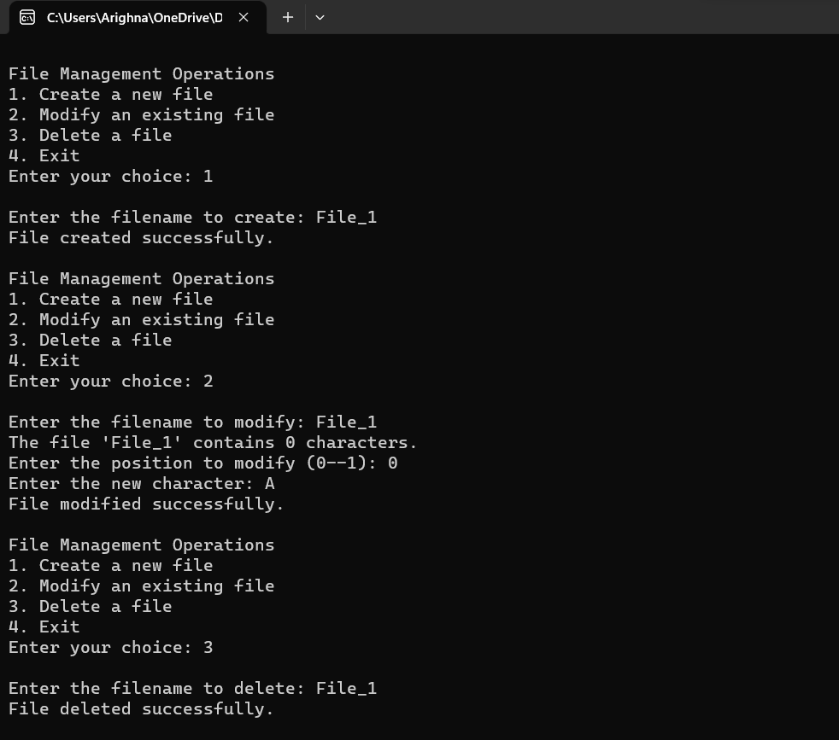

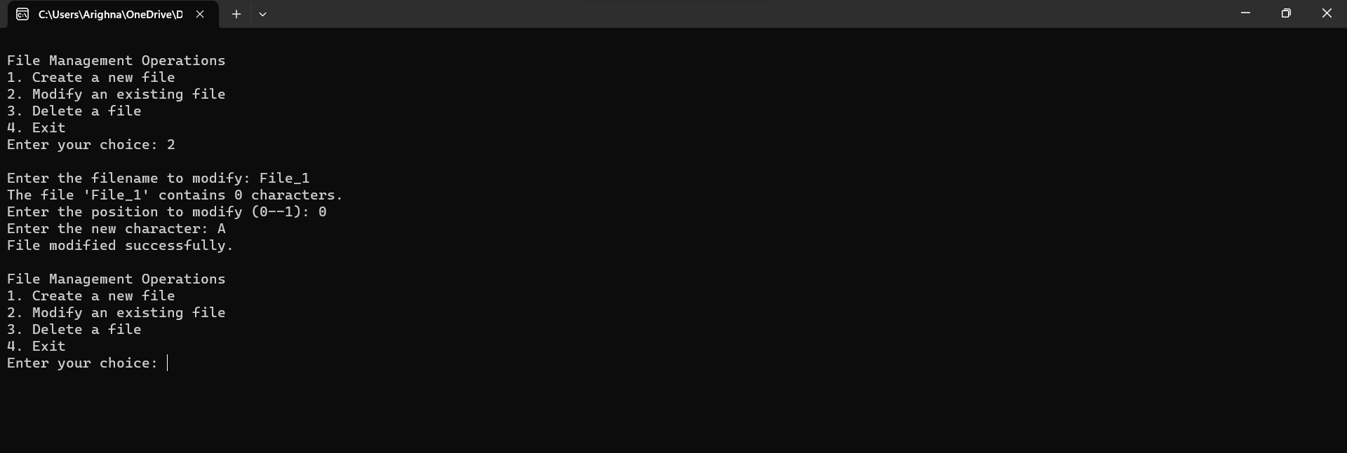

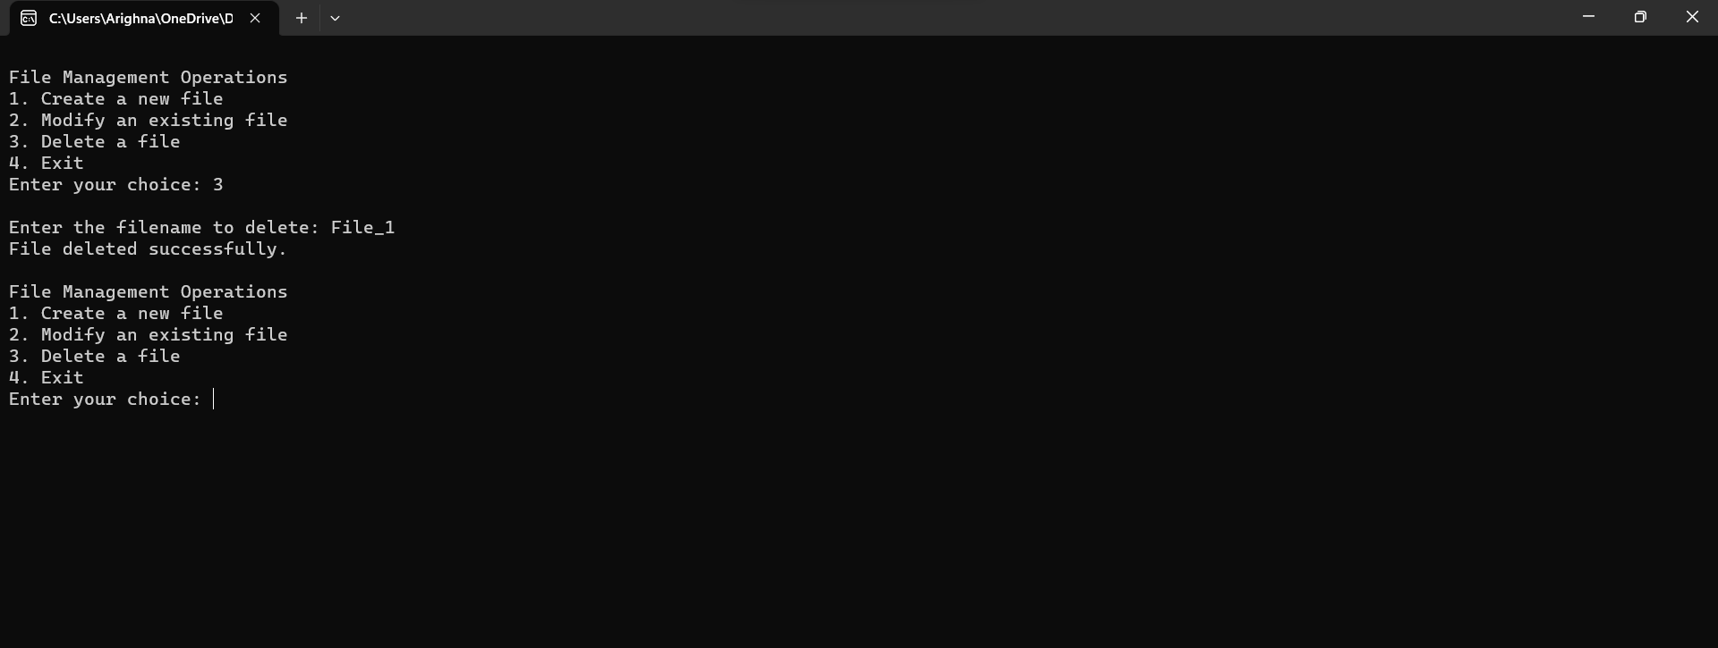

***Functions :***

**int main() –** This is the only function , which performs all the tasks given in the code.

***Variable Description:***

|  |  |  |
| --- | --- | --- |
| Variable Name | Data type | Variable Description |
| filename | char | This is a array type which stores the file. |
| ch | char | This takes the character as input. |
| choice | int | It takes choice as input. |
| position | int | It takes the position as input. |